The College of Dental Surgeons of Hong Kong | 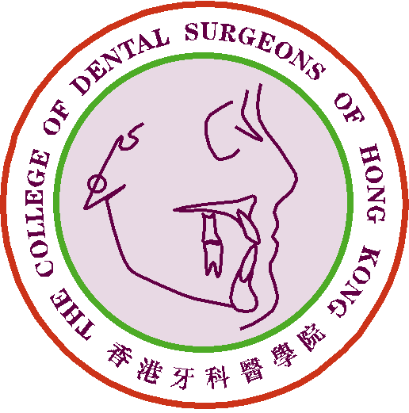

Claim Form for CME/CPD Programme

Personal Data |  | Date of Submission :
Name of Applicant : |  | Phone No.:
Email address: |  | Fax No.:

Please ☑ one only :
1) Fellow or Specialist |  |  | 2) MGD Holder |  |  | 3) Specialist Trainee

a) Please email this document in “word” format to cme_cpd@cdshk.org for processing
b) Please save the file name as “Full Name” + “Date” (e.g. Dr. CHAN Tai Man – 2020-01-01)

<*> must be completed
Self Study
Remarks: | 1) the article submitted must be within the most recent 3 years with respect to the date of submission;  2) a soft copy of the 1st page of the article has to be attached together with this application.
Report Date: |  |  |  |  | No. of CME point(s) claimed:
Name of Journal / Self Assessment Programme:
*Name of Article:
*Volume of Journal:  (year / volume / page no.) |  |  | Year: |  |  | Volume: |  | Pages:
Summary of Contents:
(not less than 100 words)
 |  |  |  |  |  |  |  | No. of words:

Critical assessment of the value of the material studied
(not less than 100 words)
No. of words:

Guidelines:
- The self-study materials must be dentally or medically oriented including i) scientific paper; ii) books/book chapters/monographs published by professional publishers; and iii) network educational programme/e-learning materials presented by academic institutions, professional bodies or government agents, and must be published within the most recent 3 years, counting from the date of submission of self-study.
- The summary should describe the background of the subject area, main contents of the materials and conclusions or suggestions (at least 100 words)
- A critical assessment should be submitted, consisting of a brief review of the subject area and rationale for the issue, scientific values of the material, clinical implications, critical views, recommendations and perspectives etc (at least 100 words)

For Official Use Only | Points Awarded:
For Official Use Only | Total | CME point(s)

- The CME Subcommittee has the rights to evaluate, approve, review and revise the CME point(s) for the above activity/activities.
- Please send this form and other supporting documents by e-mail to cme_cpd@cdshk.org for processing after completion.

(Please make photocopies of these forms whenever applicable or download from
CDSHK website under “Forms Download”: http://www.cdshk.org/Forms/index.htm)

